St. Paul Ev. Lutheran Church
405 Emma
Chenoa, Il 61726

September 28, 2023
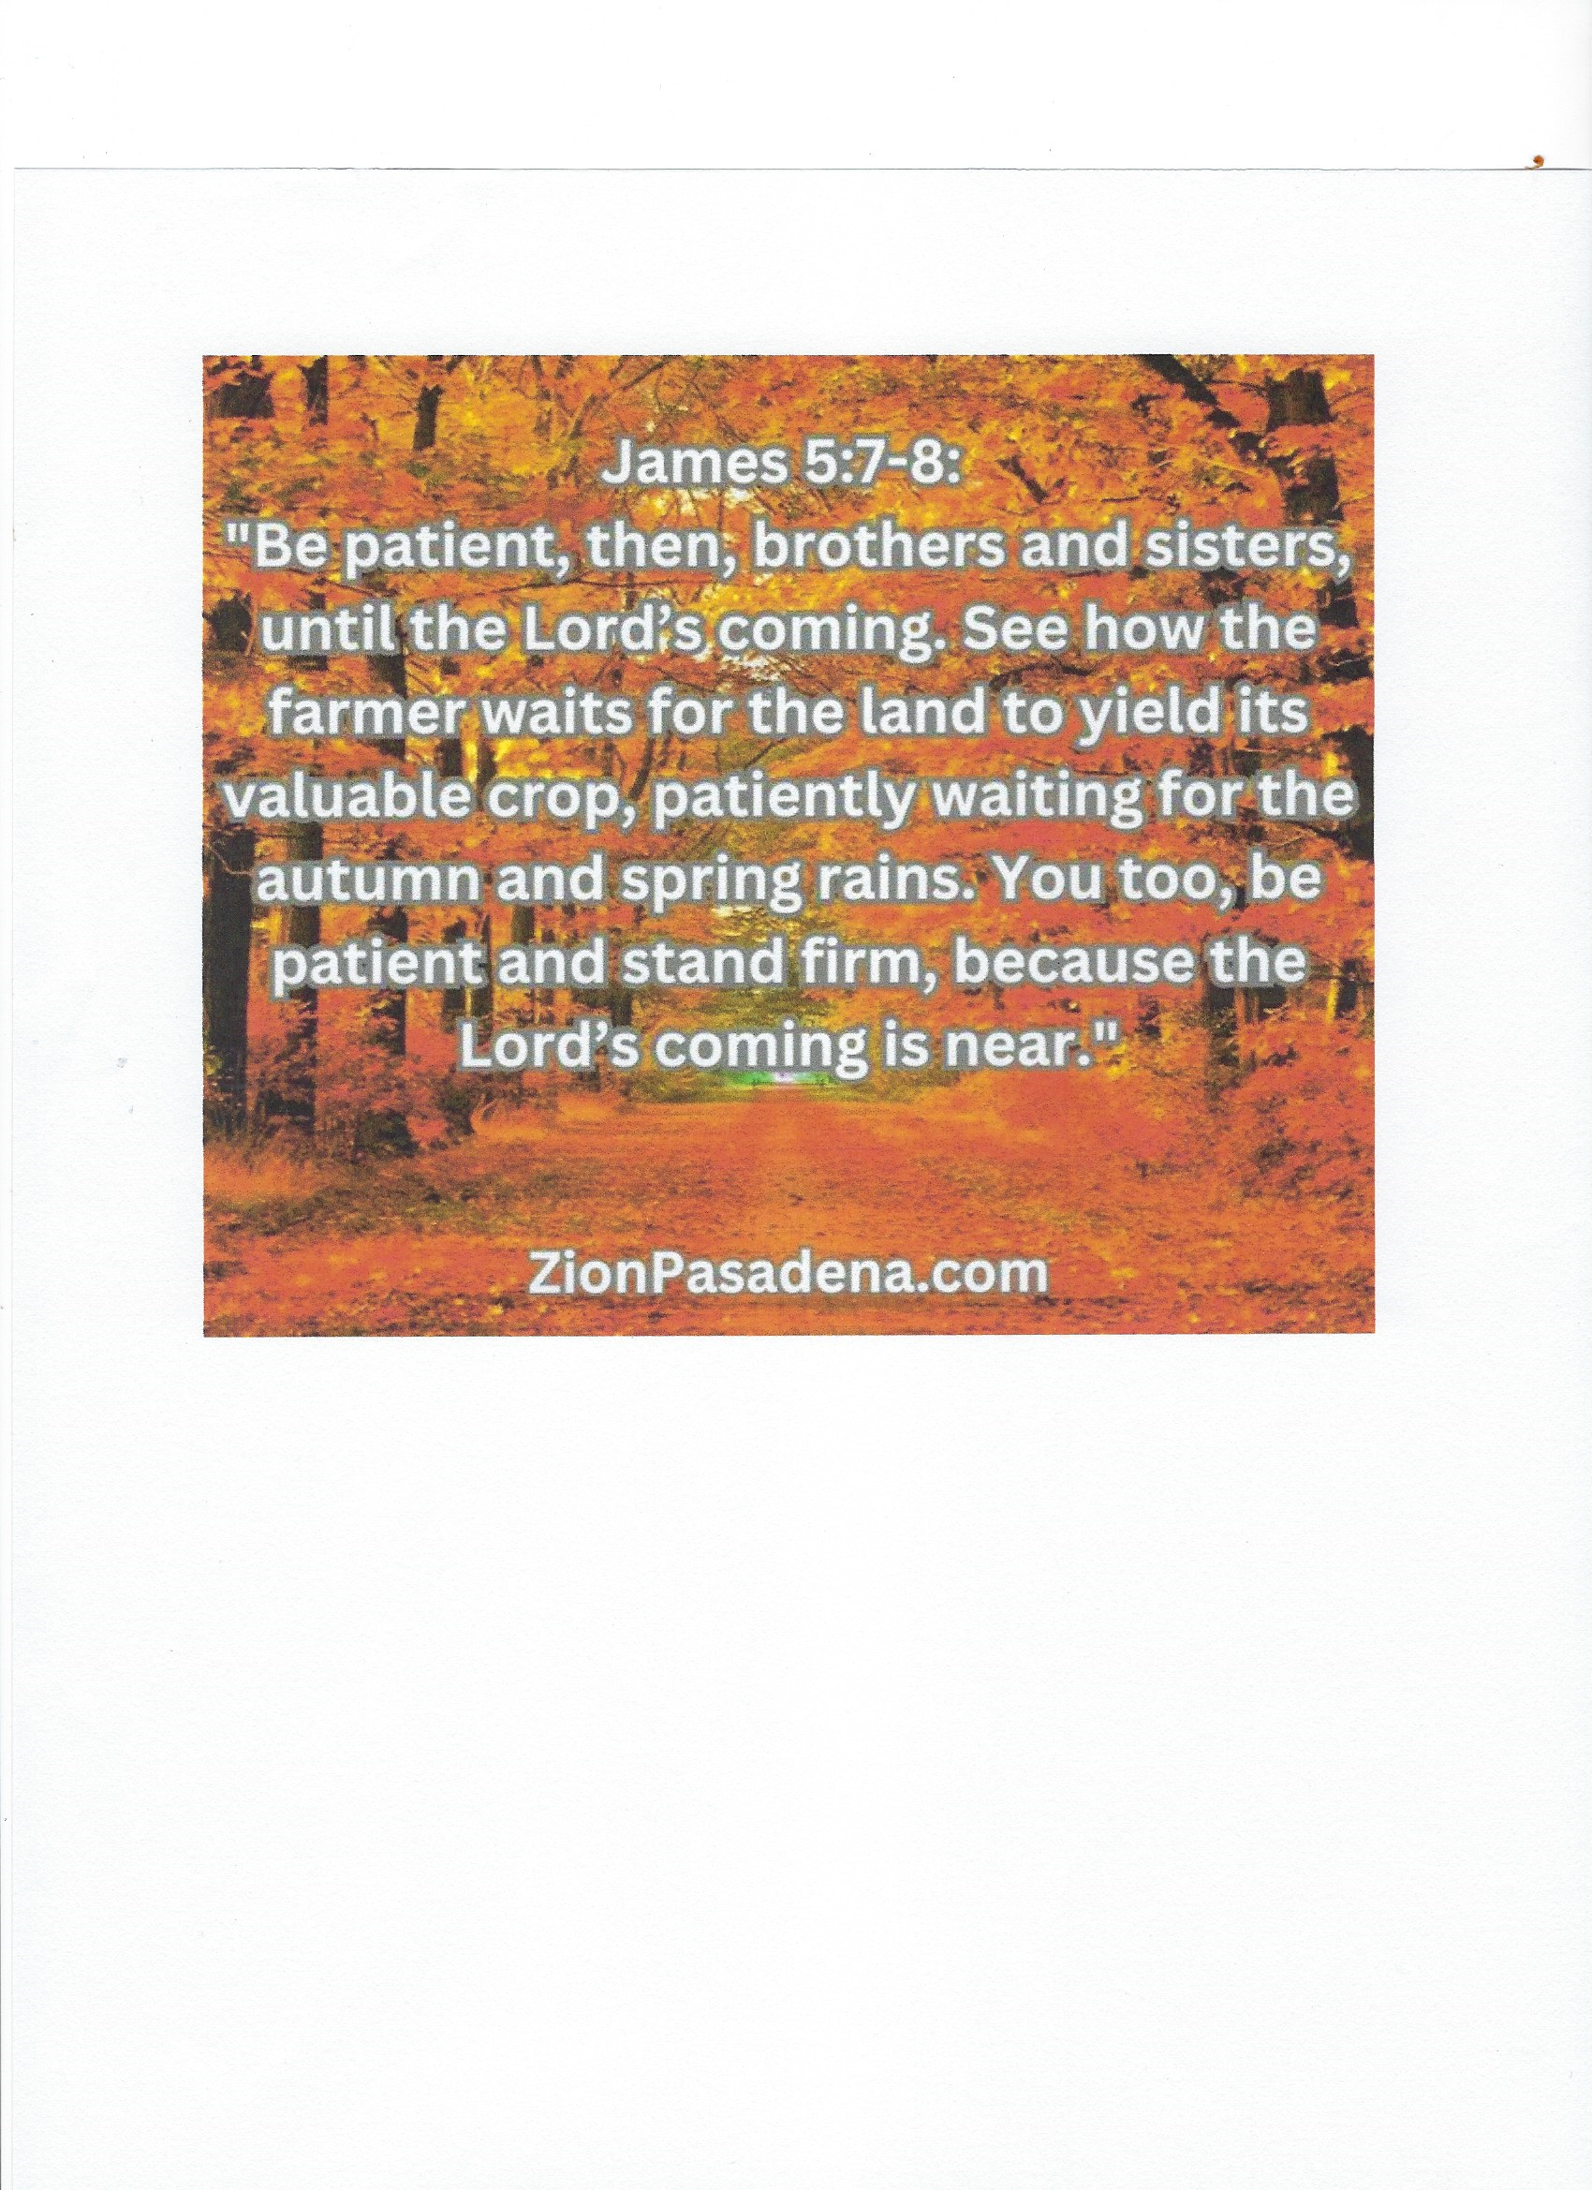

ST. PAUL DISCIPLESHIP

Date Attnd Offering Mission

09-03 54 5470.92 20.00
09-10 68 4253.44
09-17 86
09-24 67
Debt Retirement 100.00
Ladies Restroom Renovation 450.00
Seminary Student 1100.00

We will have openings for two new Elders and a Chairman next year.
Anyone interested please talk to a current Elder or Tom Norris.”

The first ladies Bible Study will be held on Wednesday October 4 at 6:30 pm at our Church. The group will decide the following:--Future meeting dates and times---Which Concordia Publishing House Bible studies to start with. and the Church will order whatever books we need for the Bible Study. Guests are welcome.

NEEDING OUR CONTINUING PRAYER
Jack Brandt
Alma Brucker
Earl Ellinger
Stacie Hensley
Ethan Jeffreys[now on chemo, friend of Diane Brandt’s]
Family of Bill Ledford [who passed away this past week]

Dr.Jim May [cousin of Pat Wahls]
Carla Nobis
Matthew Patternoster [friend of Ben Rhoda]
Penny Rhoades [friend of Kurt and Kim Rhoda]
Gerald Schuler
Leda Thacker [at Fairview Haven]
Rick Trachsel
Lee Wahls
Pat Wahls
[friends of Mike Shrewsbury listed below]
Phillip
Tim
Larry

Please notify Joy if anyone could be removed from the Prayer List.

St. Jude Garage Sale here at our church October 6th and 7th. If you have any items for the Garage Sale, you can bring them any time before Friday, October 6th. All proceeds go to St. Jude.

We would like to extend a special thank you to Lois for organizing and putting together the baby basket for our newest grandson Maverick August and for her special handmade gifts. We really appreciate the special kindness and gratitude everyone here at St Pauls has showed our family with the generous donations and monetary gifts.
Thanks again,,
Normalynne and Gary Bashford

Our sincere thanks and appreciation to all those who delivered Peace Meals this past month. Your efforts are greatly appreciated.
Thank you to: Fred Rhoda, Diane Brandt, Darrel Nobis, Harold Hensley, Lois Pulaski, Judy Bertsche, Kathy Trachsel, Carolyn Shane, Sharon Barrett, Gerald and Ramona Schuler, Bob and Nancy Nylander, and Angie Brandt. It should be noted that Fred delivered both on Mondays and Fridays.

The ladies bathroom project is moving forward. The total is $85,000 with 10% contingency. We would like to raise an additional $10,000 to avoid depleting Savings or borrowing. Questions, please contact a trustee.

October is Pastor’s Appreciation Month – during the month of October, a basket will be located in the narthex for collection of cards, gifts, monetary gifts for Pastor Ronchetto. We certainly do appreciate all that he does for our congregation.

It was nice seeing everyone for Book Club again. We chose our next two reads and hope you enjoy them.

For October we will be reading The In-Between by Hadley Vlahos. This extraordinary book helps us dispel fear around death and dying and that it is a natural part of our soul’s evolution. Please join us on Thursday October 19th at 6:30 for this inspirational discussion.
In November we will be reading Lessons in Chemistry by Bonnie Grams. A gifted research chemist, Elizabeth Zott, has a major detour in her career when she becomes the unlikely star of a beloved TV cooking show. We will meet Thursday November 16th at 6:30.

