St. Paul Ev. Lutheran Church
405 Emma
Chenoa, Il 61726

November 29, 2023

You Go to Bethlehem Only Once…

The shepherds made this trip to Bethlehem only once, but the day after their visit would last all their lives. Only once they heard the angels sing and only once they saw Christ in the manger. But what hymns of praise filled their remaining lives! With the hymns of the angels in their ears they went to Bethlehem, but with their own hymns of praise in their ears they returned. We can be sure that the “glorifying and praising God” was not only characteristic of their return to their flocks, but of all their remaining lives.

Let each one put himself in the place of the shepherds and be reminded once again that the day after Christmas is more important than Christmas itself. We will have Christmas anyway, even if it is not a conscious religious need that leads us there. Christmas comes to us as a custom or social demand. But the real issue revolves around our return from Christmas. Will those around us recognize that we have been among the ones who visited Bethlehem? This is the crux of the matter—it is the day after Christmas that proves the genuineness of our visit to Bethlehem.

If our celebration is just participation in an annual custom, the path of our return will lead us back to our everyday lives exactly as we left them. But if Christmas is something more; if, although unworthy, we truly meet Christ in Christmas, our path of return will lead us to something different than previous days.

ST. PAUL DISCIPLESHIP

Date Attnd Offering Mission

11-05 75 4045.00
11-12 65 1853.00
11-19 70 2153.00 10.00
11-22 40 873.00
11-26 66 2041.00
Debt Retirement 900.00
Ladies Restroom Renovation 699.93
Seminary Student 50.00
Ladies Bakeless Sale 50.00

NEEDING OUR CONTINUING PRAYER
Jack Brandt [at home on palliative care]
Alma Brucker
Earl Ellinger
Stacie Hensley
Ethan Jeffreys[now on chemo, friend of Diane Brandt’s]
Patty Kelleher [Kim Rhoda’s sister-in-law]
Family of John Krummick [Gerald and Ramona’s neighbor who passed away]

Dr.Jim May [cousin of Pat Wahls]
Carla Nobis
Matthew Patternoster [friend of Ben Rhoda]
Penny Rhoades [friend of Kurt and Kim Rhoda]
Gerald Schuler
Leda Thacker [at Fairview Haven]
Nancy Todd [friend of Kurt & Kim Rhoda]
Lee Wahls
Pat Wahls
[friend of Mike Shrewsbury listed below]
Tim

Please notify Joy if anyone could be removed from the Prayer List.

The Annual Voters’ Meeting was held after worship on Sunday, November 12. The budget for 2024 was approved and the Voters voted Yes to pursue a dual parish with St. Paul, Lexington.

Since Advent services will be on Wednesday evenings, the Ladies’ Bible Study group will be meeting on Tuesday evenings from 6:30-7:30 p.m. at the church, continuing on 12/05.
Once we have completed the current Bible Study on forgiveness, we will wait to start the next study until after January 1 instead of Tuesday evenings, we will be meeting 2-3 p.m. on Wednesday afternoons.

We will be studying “Joy: a study of Philippians”. Study books will be available closer to the starting date. Please let Tom Norris know if any questions

In November a basket was placed in the narthex for a Christmas collection for our adopted Seminary Student. Donations need to be received by December 3. If you wish to donate by a check, it can be made to St. Paul Lutheran as one check will be issued to David Krueger.

Bake-less Bake Sale—It is time once again for the Ladies of the Church’ Bake-less Bake Sale. The Ladies sponsor a seminary student throughout the year by sending monthly checks. This year our adopted seminary student is David Krueger. The Ladies also provide meals for the families at a funeral and send monies for the community Thanksgiving baskets. You can place your donation in the Sunday offering marked—Ladies or give it to Judy Bertsche or mail it to Judy Bertsche, 27651 East 2700 North Road, Chenoa IL 61726.

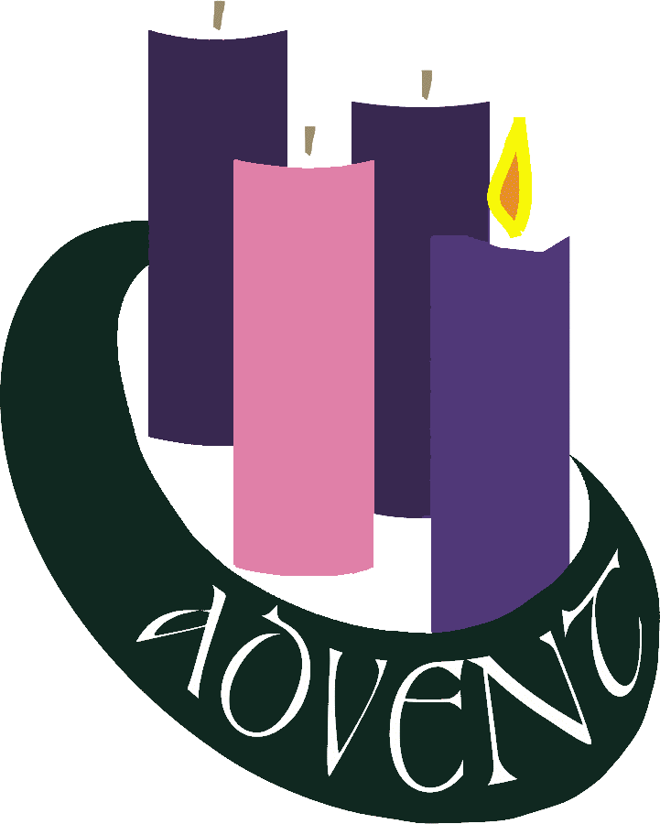

There will be three mid-week Advent Services December 6th, 13th, and 20th at St. Paul, Lexington. Soup and salad will be available starting at 5:00 PM in the fellowship hall. Advent service will begin at 5:45 PM. The soup and salad will remain available after the conclusion of the service. St. Paul, Chenoa will be responsible for the soup/salad supper on December 20th.

Book Club - Our December gathering will be at The Easley’s on December 14th at 6pm. Everyone is to select their favorite children's book and tell us something special about the book and/ or author. We will be having soup and dessert. Hoping everyone can join us for this evening of fellowship and fun! We welcome new readers to our group.

Don’t forget to bring ideas for good reads for the new year.

St. Paul, Lexington and St. Paul, Chenoa ladies are planning a Baby Shower for Pastor and Kayla Ronchetto’s baby boy on December 16th, 1:30 PM at Lexington. There is a sign-up sheet outside Joy’s office if you are planning to attend. They are registered at Target and items can be shipped directly to their house. Instead of greeting cards Kayla suggested to use a book, perhaps a favorite of your child.
[If you are not going to be able to attend and would like to contribute to a Target gift card, please see Joy]

